Programma concert zondag 19 januari 2020

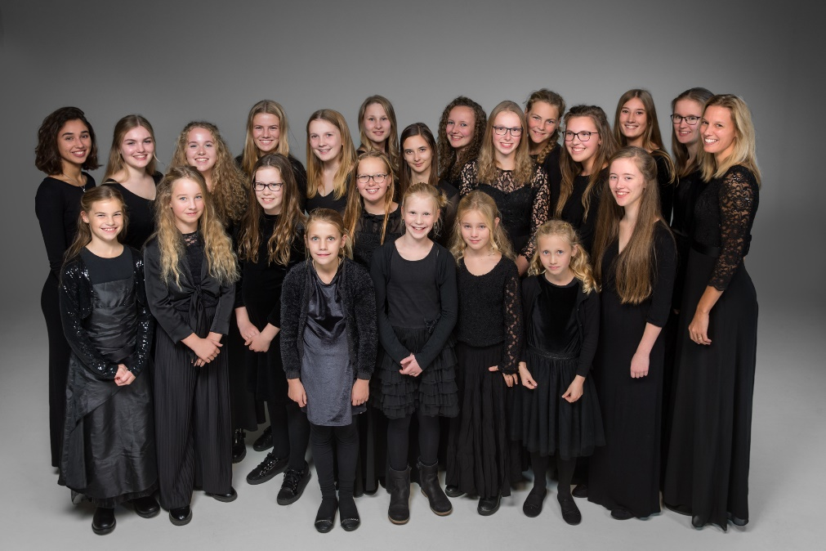

Here, here a Light: Anglican cathedral music
Roden Girl Choristers o.l.v. Sonja de Vries
Roden Girl Voices (senior ensemble) o.l.v. Sonja de Vries
Orgel: Sietze de Vries

Programma

A Song of Trust Charles Villiers Stanford 1852 – 1924

O hear us Lord Anthony Piccolo * 1947

Like as the hart Noel Rawsthorne *1929

Magnificat in E flat Major David Hogan 1949 - 1996

Te Deum Herbert Howells 1892 – 1983

Here, here a Light Joel Martinson *1960

Organ improvisation Sietze de Vries *1973

Domine Exaudi George Malcolm 1917 - 1997

O give thanks unto the Lord John Rutter *1945

It is a thing most wonderful John Ireland 1979 - 1962

Cry out with Joy to the Lord Richard Lloyd *1933

Drop, drop slow tears Frank Bridge 1879 – 1941

A Song of Battle Charles Villiers Stanford

Roden Girl Choristers
Het meisjeskoor, de Roden Girl Choristers, bestaat sinds september 2000 en zet zich in voor het ontwikkelen van jong zangtalent. Het koor maakt deel uit van Stichting Koorschool Noord Nederland. Deze dynamische groep meiden, onder leiding van artistiek leider Sonja de Vries, heeft zich inmiddels een klinkende reputatie verworven. Het doel van de Roden Girl Choristers is om referentiepunt te zijn voor meisjeskoorzang in Nederland.

Jonge meisjes worden in het opleidingstraject voorbereid op een auditie als chorister. Individuele stemvorming resulteert in een eenvormige koorklank waarbij elk koorlid zich met zelfvertrouwen inzet. Een zelfvertrouwen dat bovendien versterkt wordt door de sociale hechtheid van de groep. Geschoeid op Anglicaanse leest, wordt het koor geïnspireerd door het heldere, strakke, open klankidioom van de Engelse jongens- en meisjeskoren. Ook wat repertoirekeus betreft vormt de Anglicaanse koortraditie een onuitputtelijke bron van inspiratie. Studiereizen naar Engeland, met masterclasses door collega-dirigenten, vinden met enige regelmaat plaats. Uitwisselingen met collega-koren uit Engeland, zoals dat van St. John’s College, Cambridge en het University Choir van St. Andrews dragen ook bij aan de muzikale vorming van de choristers.

Het koor musiceert op topniveau en heeft een plaats op de belangrijkste concertpodia in heel Nederland en in het buitenland. Met ongeveer 20 concerten per jaar en concertreizen in binnen- en buitenland bereiken de Roden Girl Choristers een grote schare enthousiaste toehoorders. Het koor heeft radio- en televisieopnames gemaakt voor Radio 4, IKON en de EO. De choristers werken mee aan grote producties voor koor en orkest, zoals Carmina Burana van Carl Orff en Mass of the children van John Rutter. De Matthäus Passion van Johann Sebastian Bach onder de bezielende leiding van Reinbert de Leeuw (lid van het Comité van Aanbeveling) in 2016, vormde een bijzonder hoogtepunt!

Een aantal van de oudste solisten vormt samen een eigen ensemble, de Roden Girl Voices. Wat repertoirekeus betreft, gaan ze de uitdaging aan. De vaste begeleider van het koor is organist Sietze de Vries. www.rodengirlchoristers.nl

Volgende concert:
Zondag 16 februari 2020 – 15.00 uur

DUO PUUR

Van oud tot jong

A Song of Trust Charles Villiers Stanford 1852 - 1924
From: Six Bible Songs, Opus 113
Words: Psalm 121

I will lift up mine eyes unto the hills.
From whence cometh my help?
My help cometh even from the Lord
Who hath made heaven and earth.
He will not suffer thy foot to be moved.
And he that keepeth thee will not sleep.
Behold, he that keepeth Israel
shall neither slumber nor sleep.
The Lord himself is thy keeper:
The Lord is thy defence upon thy right hand.
So that the sun shall not burn thee by day,
Neither the moon by night.

I will lift up mine eyes unto the hills.
From whence cometh my help?
My help cometh even from the Lord
Who hath made heaven and earth.
The Lord shall preserve thee from all evil.
Yea, it is even he that shall preserve thy soul.
The Lord shall preserve thy going out and thy coming in,
From this time forth for ever more.

O Hear us, Lord Anthony Piccolo *1947
Words: John Donne

Hear us, O hear us, Lord;
To Thee a sinner is more music, when he prays,
than spheres' or angels' praises be,
in panegyric alleluias.
Hear us, for till Thou hear us, Lord,
we know not what to say.
Thine ear to our sighs, tears, thoughts, gives voice and word.
O Thou, who Satan heardest in Job's sick day,
hear Thyself now, for Thou in us dost pray.

Like as the hart Noel Rawsthorne * 1929
Words: Psalm 42:1-3
Like as the hart desireth the water-brooks,
So longeth my soul after thee, O God.
My soul thirsts for the living God,
Yea, even he that shall keep my soul.
My tears have been my meat day and night,
While they daily say unto me:
Where is now thy God?

Magnificat in E flat Major David Hogan 1949 - 1996
Words: Luke 1: 46 – 55

My soul doth magnify the Lord: and my spirit hath rejoiced in God my Saviour.
For He hath regarded: the lowliness of His handmaiden.
For behold, from henceforth: all generations shall call me blessed.
For He, that is mighty hath magnified me: and holy is His name.
And His mercy is on them that fear Him: throughout all generations.
He hath shewed strength with his arm:
He hath scattered the proud in the imagination of their hearts.
He hath put down the mighty from their seat:
and hath exalted the humble and meek.
He hath filled the hungry with good things: and the rich He hath sent empty away.
He remembering His mercy hath holpen his servant Israel,
as He promised to our forefathers, Abraham and his seed, forever.
Glory be to the Father and to the Son and to the Holy Ghost.
As it was in the beginning is now and ever shall be:
world without end. Amen.

Te Deum Herbert Howells 1892 - 1983

We praise thee, O God: we acknowledge Thee to be the Lord.
All the earth doth worship Thee, the Father everlasting.
To Thee all Angels cry aloud: the Heavens and all the powers therein.
To Thee Cherubim and Seraphim continually do cry, Holy, Holy, Holy:
Lord God of Sabaoth;
Heaven and earth are full of the Majesty of Thy Glory.
The glorious company of the Apostles praise Thee.
The godly fellowship of the Prophets praise Thee.
The noble army of Martyrs praise Thee.
The holy Church throughout all the world doth acknowledge Thee;
The Father of an infinite Majesty;
Thine honourable, true, and only Son;
Also the Holy Ghost: the Comforter.
Thou art the King of Glory, O Christ.
Thou art the everlasting Son of the Father.
When Thou tookest upon Thee to deliver man:
Thou didst not abhor the Virgin's womb.
When Thou hadst overcome the sharpness of death,
Thou didst open the Kingdom of Heaven to all believers.
Thou sittest at the right hand of God in the glory of the Father.
We believe that Thou shalt come to be our Judge.
We therefore pray Thee,
help Thy servants whom Thou hast redeemed with Thy precious blood.
Make them to be numbered with Thy Saints in glory everlasting.

O Lord, save Thy people: and bless Thine heritage.
Govern them and lift them up for ever.
Day by day we magnify Thee; and we worship Thy Name, ever world without end.
Vouchsafe, O Lord, to keep us this day without sin.
O Lord, have mercy upon us.
O Lord, let Thy mercy lighten upon us: as our trust is in Thee.
O Lord, in Thee have I trusted: let me never be confounded.

Here, here a Light Joel Martinson *1960
Roden Girl Voices

Here, a Light which we can bear to look at.
And looking at must adore.
It comes to us from a Light we cannot bear to look at.
To look at even while we worship it.
Here Eternal Reality is given in human terms.
Here Eternal Reality convinces us of beauty, the reality of holiness.
Here we are shown Truth pouring through the windows of holiness.
And are molded for the true purpose of our creation:
A life of charity united to the selfgiving generosity which is God.

Here, a Light which is God.

Organ improvisation Sietze de Vries *1973

Domine Exaudi George Malcolm 1917 - 1997
Words: Psalm 102: 1,2
Roden Girl Voices

Domine, exaudi orationem meam, et clamor meus ad te per veniat.
Ne avertas faciem tuam a me

Hear my prayer, O Lord: and let my crying come unto thee.
Hide not thy face from me

O give thanks unto the Lord John Rutter *1945
Words: Psalm 67 en Psalm 136

O give thanks unto the Lord, for He is gracious:
And His mercy endureth for ever.
O give thanks tot he God of all gods:
For His mercy endureth for ever.
O thank the Lord of all lords:
For His mercy endureth for ever.
Who only doeth great wonders:
For His mercy endureth for ever.
Who by his excellent wisdom made the heavens:
For His mercy endureth for ever.
Who laid out the earth above the waters:
For His mercy endureth for ever.
Who hath made great lights:
For His mercy endureth for ever.
The sun to rule the day:
For His mercy endureth for ever.
The moon and the star to govern the night:
For His mercy endureth for ever.

God be merciful unto us and bless us:
and shew us the light of his countenance and be merciful unto us.
That thy way may be known upon the earth,
thy saving health among all the nations:
for his mercy endureth forever.

Glory be to the Father, and to the Son and to the Holy Ghost.
As it was in the beginning, and is now, and ever shall be: world without end.
Amen.

Ex ore innocentium John Ireland 1879 – 1962
Words: Bishop W.W. How

It is a thing most wonderful,
almost too wonderful to be,
that God’s own Son should come from heav’n,
and die to save a child like me.

And yet I know that it is true:
He chose a poor and humble lot,
and wept, and toiled, and mourned and died…
for love of those who loved him not.

I sometimes think about the cross,
and shut my eyes, and try to see
the cruel nails and crown of thorns,
and Jesus crucified for me.

But even could I see him die,
I should but see a little part
of that great love which like a fire
is always burning in his heart.

And yet I want to love thee Lord,
O light the flame within my heart,
and I will love thee more and more,
until I see thee as thou art.

Cry out with Joy to the Lord Richard Lloyd *1933
Words: Psalm 100

Cry out with joy to the Lord, all the earth;
Serve the Lord with gladness.
Come before him, singing for joy.
Know that he, the Lord, is God;
He made us, we belong to him.
We are his people, the sheep of his flock.

Go within his gates, giving thanks.
Enter his courts with songs of praise.
Give thanks to him and bless his name.
Indeed, how good is the Lord;
Eternal his merciful love.
He is faithful from age to age.

Drop, drop slow tears Frank Bridge 1879 – 1941
Words: Phineas Fletcher
Roden Girl Voices

Drop, drop, slow tears,
And bathe those beauteous feet
Which brought from Heaven
The news and Prince of Peace.
Cease not, wet eyes,
His mercy to entreat;
To cry for vengeance
Sin doth never cease.
In your deep floods
Drown all my faults and fears;
Nor let His eye
See sin, but through my tears.

A Song of Battle Charles Villiers Stanford
From: Six Bible Songs, Opus 113
Words: Psalm 124

If the Lord himself had not been on our side, now may Israel say:
If the Lord himself had not been on our side, when men rose up against us;
Then they had swallowed us up alive: when their wrath was kindled against us.
Then the waters had overwhelmed us:
The stream had gone over our soul.
Then the proud waters: had gone even over our soul.
Blessed be the Lord: who hath not given us as a prey unto their teeth.
Our soul is escaped even as a bird from the snare of the fowlers:
The snare is broken, and we are delivered.
Our help is in the name of the Lord: who made heaven and earth.

